Physics 30 Lesson 3B Conservation of Energy I

Conservation of Energy
The law of conservation of energy states that the total amount of energy in a system remains constant. Energy may be transformed from one type to another, from kinetic to potential or kinetic to heat, but the total amount of energy is conserved.
Initial Total Energy = Final Total Energy

This is a very powerful principle or law, and we will be using it in one form or another throughout the entire Physics 30 course. In this unit, we shall use it to solve problems which would be quite difficult if we were only using kinematics or dynamics. The basic method for solving problems of this type is as follows:

1. Determine the different forms of energy that are present at the beginning of the problem.
- Write a mathematical equation expression including all of the gravitational potential, elastic potential and kinetic energies.
- If work is being done, add that energy in as well.

2. Determine the different forms of energy that are present at the end of the problem.
- Write a mathematical equation expression including all of the gravitational potential, elastic potential and kinetic energies.
- If work is being done, add that energy in as well. Friction is a form of work.

3. Initial total energy = Final total energy

4. Solve for the requested value.

A 50 kg object falls 490.5 m. What is the speed of the object just before impact with the ground?
Total initial energies = Total final energies
Potential energy at top = kinetic energy at the bottom
E_{p} = E_{k}
m g h = ½ m v²
v = 98.1 m/s

A snowmobile driver with a mass of 100 kg traveling at 50 m/s slams into a snow drift. If the driver sinks 0.50 m into the snow drift before stopping, what is the retarding force applied by the snow drift?

E_{K} = ½ m v² = ½ (100 kg) (50 m/s)² = 125 kJ

The snowmobile driver has a kinetic energy of 125 kJ. In other words he can do 125 kJ of work on the snow drift. But, since the snow drift stops the driver, it must do 125 kJ of work on the driver.
= 2.5 x10⁵ N

A 5.0 gram bullet enters a wooden block at 350 m/s and exits the 20 cm wide block at 150 m/s. What was the force applied to the bullet by the block?

Total initial energies = Total final energies

initial kinetic energy of bullet = final kinetic energy + work done by block
E_{ki} = E_{kf} + W_{block}
½ m v_{i}² = ½ m v_{f}² + F_{f} d
F_{f} = ½ m v_{i}² - ½ m v_{f}²
d
F_{f} = ½(0.0050 kg)(350 m/s)² - ½(0.0050 kg)(150 m/s)²
0.20 m
F_{f} = 1250 N

A 5.0 kg object is thrown vertically down from the top of a 50 m tower with a speed of 15.0 m/s. What is the speed of the object at the bottom of the tower just before it hits the ground?

Total initial energies = Total final energies

E_{pi} + E_{ki} = E_{kf}
m g h + ½ m v_{i}² = ½ m v_{f}²
v_{f}² = m g h + ½ m v_{i}²
½ m
v_{f}² = 9.81 m/s²(50 m) + ½(15.0 m/s)² = 1206
½
v_{f} = 34.7 m/s

A 100 kg object is raised 10 m and then released. What is the speed of the object 2.0 m above the ground?

Total initial energies = Total final energies
E_{pi} = E_{pf} + E_{kf}
m g h_{i} = m g h_{f} + ½ m v_{f}²
v_{f}² = g h_{i} - g h_{f}
½
v_{f}² = 9.81 m/s²(10 m) - 9.81 m/s²(2.0 m) = 156.96
½
v_{f} = 12.5 m/s

Consider an object sliding down an inclined plane. A 25 kg object resting at the top of a 15 m high inclined plane begins to slide down the plane. At the bottom of the plane the object has a speed of 14.0 m/s.

A. How much heat energy was produced?

Initial energy = Final energy

E_{p} = E_{k} + E_{H}

m g h = ½ m v² + E_{H}

E_{H} = m g h - ½ m v²

E_{H} = 25 kg (9.81 m/s²) (15 m) - ½ (25 kg) (14.0 m/s)²

E_{H} = 1.23 kJ

B. If the incline is 35.0 m long, what is the frictional force?

E_{H} = F_{f} d

F_{f} = E_{H} = 1228.75 J = 35.1 N
d 35.0 m

F_{f} = 35.1 N

Practice Problems
1. A motorcycle rider is trying to leap across the canyon as shown in the figure by driving horizontally off the cliff. When it leaves the cliff, the cycle has a speed of 38.0 m/s. Ignoring air resistance, find the speed with which the cycle strikes the ground on the other side. (46.2 m/s)

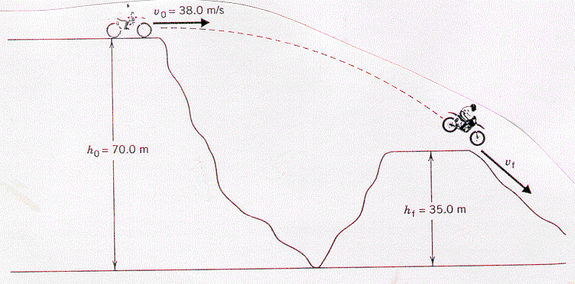

2. A 6.00 m rope is tied to a tree limb and used as a swing. A person starts from rest with the rope held in a horizontal orientation, as in the figure. Ignoring friction and air resistance, determine how fast the person is moving at the lowest point on the circular arc of the swing. (10.8 m/s)
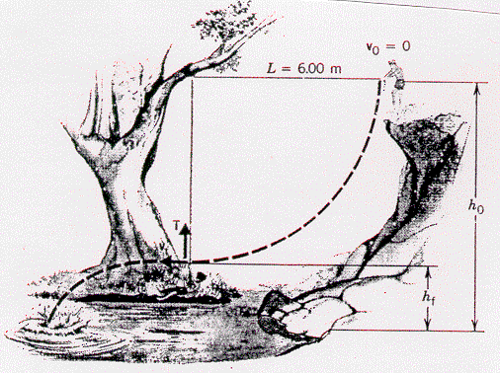

3. One of the fastest roller coasters (2000 kg) in the world is the Magnum XL - 200 at Cedar Point Park in Sandusky, Ohio. This ride includes an initial vertical drop of 59.3 m. Assume that the roller coaster has a speed of nearly zero as it crests the top of the hill.

A. If the track was frictionless, find the speed of the roller coaster at the bottom of the hill. (34.1 m/s)

B. The actual speed of the roller coaster at the bottom is 32.2 m/s. If the length of track is 125 m, what is the average frictional force acting on the roller coaster? (1.01 x 10³ N)

Hand-in Assignment
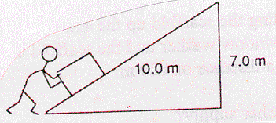
1. An 80.0 kg box is pushed up a frictionless incline as shown in the diagram. How much work is done on the box in moving it to the top? (Hint, think energy, not forces.) (5.49 kJ)

2. A 75 g arrow is fired horizontally. The bow string exerts an average force of 65 N on the arrow over a distance of 0.90 m. With what speed does the arrow leave the bow string? (39 m/s)

3. In the high jump, the kinetic energy of an athlete is transformed into gravitational potential energy. With what minimum speed must the athlete leave the ground in order to lift his center of mass 2.10 m and cross the bar with a speed of 0.80 m/s? (6.5 m/s)

4. A 50.0 kg pole vaulter running at 10.0 m/s vaults over the bar. Assuming that the vaulter's horizontal component of velocity over the bar is 1.00 m/s and disregarding air resistance, how high was the jump? (5.05 m)

5. If a 4.00 kg board skidding across the floor with an initial speed of 5.50 m/s comes to rest, how much thermal energy is produced? (60.5 J)

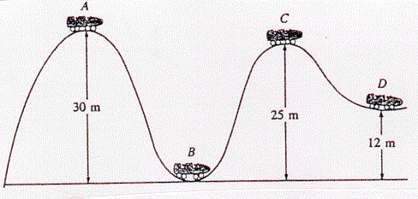
6. A roller coaster is shown in the drawing. Assuming no friction, calculate the speed at points B, C, D, assuming it has a speed of 1.80 m/s at point A. (24.3 m/s, 10.1 m/s, 18.9 m/s)

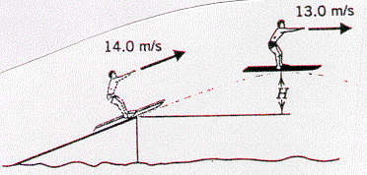
7. A water skier lets go of the tow rope upon leaving the end of a jump ramp at a speed of 14.0 m/s. As the drawing indicates, the skier has a speed of 13.0 m/s at the highest point of the jump. Ignoring air resistance, determine the skier’s height H above the top of the ramp at the highest point. (1.38 m)

8. A roller coaster vehicle with occupants has a mass of 2.9 x 10³ kg. It starts at point A with a speed of 14 m/s and slides down the track through a vertical distance of 25 m to B. It then climbs in the direction of point C which is 36 m above B. An interesting feature of this roller coaster is that due to cost-over-runs and poor planning, the track ends at point C. The occupant is the chief design engineer of the roller coaster ride. Estimate the speed of the vehicle at point B; and then determine whether the fellow survives the ride. (26 m/s)

9. A ski jumper starts from rest 50.0 m above the ground on a frictionless track, and flies off the track at a 45.0° angle above the horizontal and at a height of 10.0 m from the ground. Disregard air resistance.
a. What is the skier's speed when leaving the track? (28.0 m/s)
b. What is the maximum height attained? (30.0 m above the ground)

10. The speed of a hockey puck (mass = 100.0 g) decreases from 45.00 m/s to 42.68 m/s in coasting 16.00 m across the ice.
a. How much thermal energy was produced? (10.17 J)
b. What frictional force was acting on the puck? (0.6357 N)

11. A car traveling at 50.0 km/h skids a distance of 35 m after its brakes lock. Estimate how far it will skid if its brakes lock when its initial speed is 100.0 km/h. What happens to the car's kinetic energy as it comes to rest? (140 m)

12. During an automobile accident investigation, a police officer measured the skid marks left by a car (mass = 1500 kg) to be 65 m long. If the frictional force on the car was 7.66 kN during the skid, was the car going faster than the 100 km/h speed limit before applying the brakes? (slower)

13. A 45.0 kg box initially at rest slides from the top of a 12.5 m long incline. The incline is 5.0 m high at the top. If the box reaches the bottom of the incline at a speed of 5.0 m/s, what is the force of friction on the box along the incline?
(1.3 x 10² N)

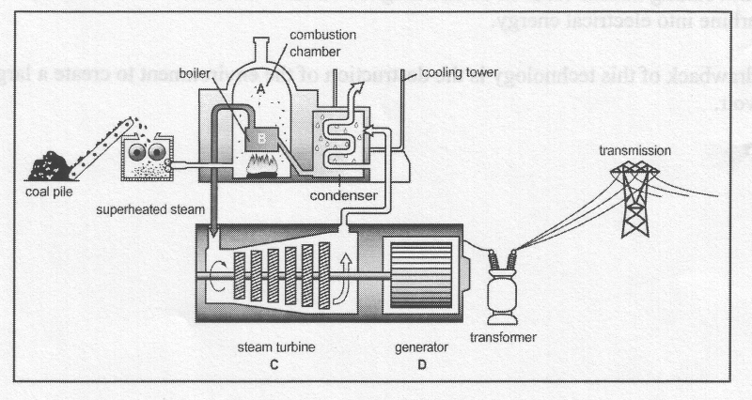
14. For a conventional coal burning power plant, the chemical potential energy in the coal is eventually converted into electricity. Using the diagram below describe the energy conversions that take place in a conventional power plant to produce electricity.

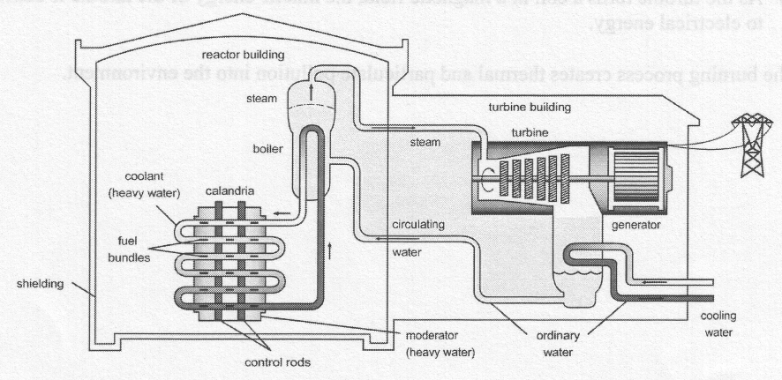
15. For a nuclear power plant, the nuclear potential energy in the uranium fuel bundles is eventually converted into electricity. Using the diagram below describe the energy conversions that take place in a nuclear power plant to produce electricity.

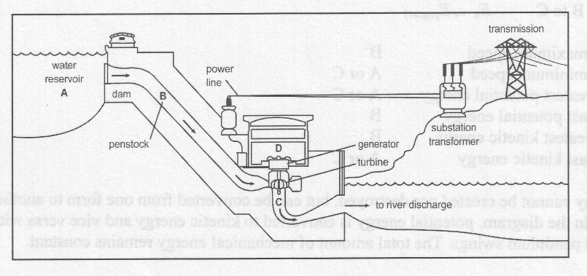
16. For a hydro electric power plant, the gravitational potential energy of the water in the dam is eventually converted into electricity. Using the diagram below describe the energy conversions that take place in a hydro electric power plant to produce electricity.

